Plot line review/“The Censors” Name: ____________________________________

[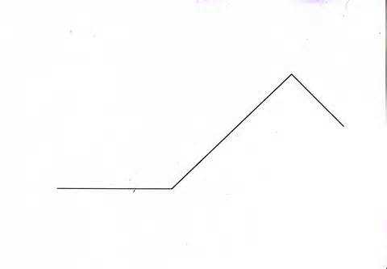](https://images.search.yahoo.com/images/view;_ylt=AwrB8p98XDlT9hcAGeeJzbkF;_ylu=X3oDMTIyZjhhNDBwBHNlYwNzcgRzbGsDaW1nBG9pZAMxZjBiM2QxODc4YzVlM2E5Mjk1MTE1N2QwYmFmNmQzNgRncG9zAzEEaXQDYmluZw--?back=http%3A%2F%2Fimages.search.yahoo.com%2Fsearch%2Fimages%3Fp%3Dplot%2Bline%26fr%3Dyfp-t-320%26fr2%3Dpiv-web%26tab%3Dorganic%26ri%3D1&w=2531&h=1757&imgurl=jockmackenzie.files.wordpress.com%2F2009%2F11%2Fplot-old-school.jpg&rurl=http%3A%2F%2Fjockmackenzie.wordpress.com%2F2009%2F11%2F30%2Fshort-story-the-picture-of-a-short-story%2F&size=265.4KB&name=Your+standard+%3Cb%3Eplot+%3C%2Fb%3Epicture&p=plot+line&oid=1f0b3d1878c5e3a92951157d0baf6d36&fr2=piv-web&fr=yfp-t-320&tt=Your+standard+%3Cb%3Eplot+%3C%2Fb%3Epicture&b=0&ni=192&no=1&ts=&tab=organic&sigr=12n0dsel7&sigb=1326grtgk&sigi=11tkepcp6&sigt=1113tn97d&sign=1113tn97d&.crumb=sKbPC/EQCtB&fr=yfp-t-320)

1. What is the author’s tone (attitude/opinion) toward the *Censor’s Secret Command*?

1. Approving C. Awed
2. Not caring D. Critical

2. What is Juan’s purpose in joining the *Post Office’s Censorship Division*?

1. To try to earn more money C. To keep anyone else from sending Mariana letters
2. To pass his own letter through to Mariana D. To support the government’s efforts to keep people safe

3. Note the following plot arc elements below and identify the category under which they all fit.

• Juan gets a job in the post office • Juan gets a promotion • Juan chooses not to participate in a worker’s strike

1. Exposition C. Rising action
2. Resolution D. Falling action/Denouement

4. In your words, what event marks the climax of the story? ___________________________________________________________

5. Read the first sentence of paragraph 6: “The building had a festive air on the outside which contrasted with its inner

**staidness**.” Which of the following most closely defines **staidness**? Consider context clues!

1. Celebration C. Confusion
2. Indifference D. Seriousness

6. Juan changes from the beginning to the end of the story. What term best describes that kind of character?

7. As you consider Juan’s change from beginning to end, think about the irony in that. Construct a sentence that articulates his change.

8. As you consider the irony, prove that it is situational irony (it is the opposite of what the reader expects).

|  |  |
| --- | --- |
| **Textual Evidence** *(that proves situational irony)* | **Explanation** *(of how that evidence proves situational irony)* |
| EXAMPLE: “Soon his work became so absorbing that his noble mission blurred his mind.” | *(you explain—hint: use your sentence above for guidance)* |
| *(you choose a direct piece of evidence)* | *(you explain)* |